8.112: a) For constant acceleration a, the downward velocity is at and the distance x that the drop has fallen is 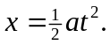 Substitution into the differential equation gives

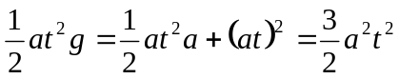,

the non-zero solution of which is 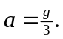

b) 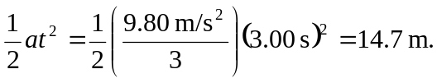
c) 